Software Requirements Specification for

MEDWLE

Prepared By:

1. Gopidi Rakshith Reddy
2. Srinath Aetukuri
3. Gowtham Varma
4. Abhinav reddy

Organization:NIIT UNIVERSITY(Under Guidance Of **DR.AMIT KUMAR**)

TABLE OF CONTENTS

Table of Contents...........................................................................................................................

Revision History.............................................................................................................................

1. Introduction.............................................................................................................................. 1.1 Purpose.................................................................................................................................

1.2 Document Conventions........................................................................................................

1.3 Intended Audience and Reading Suggestions........................................................................

1.4 Product Scope.......................................................................................................................

1.5 References............................................................................................................................

2. Overall Description..................................................................................................................

2.1 Product Perspective.............................................................................................................. 2

2.2 Product Functions.................................................................................................................

2.3 User Classes and Characteristics...........................................................................................

2.4 Operating Environment.........................................................................................................

2.5 Design and Implementation Constraints................................................................................

2.6 User Documentation.............................................................................................................

2.7 Assumptions and Dependencies...........................................................................................

3. External Interface Requirements...........................................................................................

3.1 User Interfaces.....................................................................................................................

3.2 Hardware Interfaces.............................................................................................................

3.3 Software Interfaces...............................................................................................................

3.4 Communications Interfaces..................................................................................................

4. System Features.......................................................................................................................

4.1 System Feature 1..................................................................................................................

5. Other Nonfunctional Requirements.......................................................................................

5.1 Performance Requirements...................................................................................................

5.2 Safety Requirements.............................................................................................................

5.3 Security Requirements..........................................................................................................

5.4 Software Quality Attributes..................................................................................................

5.5 Business Rules......................................................................................................................

6. Other Requirements................................................................................................................

Appendix A: Glossary...................................................................................................................

Revision History

|  |  |  |  |
| --- | --- | --- | --- |
| **Name** | **Date** | **Reason For Changes** | **Version** |
|  |  |  |  |
|  |  |  |  |

# **1. Introduction**

## **1.1 Purpose**

MEDWLE Application is planned to go about as an interface between Patients and Doctors. It will assist patients with booking meetings with specialists. It will likewise assist specialists with managing the patient's portfolio and their facility. This report is intended to portray the highlights of our Application, in order to fill in as a manual for the developers on one hand and a product approval archive for the forthcoming customer on the other Document Conventions.

## **1.2 Document Conventions**

No specific Document Conventions.

## **1.3 Intended Audience and Reading Suggestions**

The document is intended for developers, project managers, marketing staff, users, testers, and documentation writers. Follow the format in a sequential manner.

## **1.4 Product Scope**

1) Managing Patient’s Profile, which would include details of a patient, his/her appointment records, and prescriptions

2) Managing a Doctor’s profile, which would include details of a doctor, details about his/her patients, appointment and day wise schedule.

3) Giving alerts to patients for their booked appointment’s.

4) Facility to find nearby doctors.

5) Patients can reschedule the appointments according to their convenience.

6) Live availability of doctors

## **1.5 References**

This document conforms to the IEEE standard for Software Requirement Specifications

# 

# 

# 

# **2. Overall Description**

## 

## **2.1 Product Perspective**

MEDWLE plans to cross over any barrier among patients and their specialists.It is an easy to use application that will push patients to book meetings with specialists, arrange another arrangement of their continuous meds from the application itself. For specialists, it would assist them with managing their meetings with their patients, give out remedies and digitalize all the repetitive printed material. MEDWLE is planned to be a remain solitary item and ought not rely upon the accessibility of other programming. It should keep running on all android working frameworks.

2.2 **Product Functions**

## 

2.3 **User Classes and Characteristics**

## **DoctorOnTheGo should support the following use cases:**

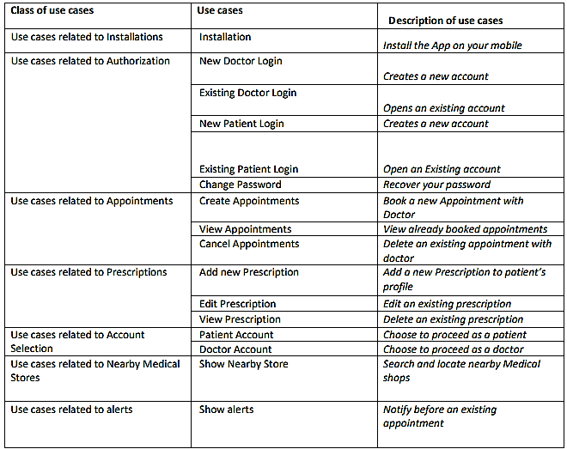

## **2.4 Operating Environment**

1) Basic hardware required is an Android Running Device with minimum Android 5.1.1 (Lollipop)

## **2.5 Design and Implementation Constraints**

1. Security: The files which store patients as well as doctor’s information should be secured against malicious deformations.

2. Fault Tolerance: Data should not become corrupted in case of Application crash or Internet failure.

## **2.6 User Documentation**

We deliver tutorials and online help through our official youtube , facebook and company mail id for better understanding and usage of software.

## **2.7 Assumptions and Dependencies**

A) Full working of MEDWLE is dependent on the availability of Internet connection.

# 

# 

# 

# **3. External Interface Requirements**

## **3.1 User Interfaces**

a. The primary Screen of the application is to choose climate the client needs to continue as a specialist or as a patient.

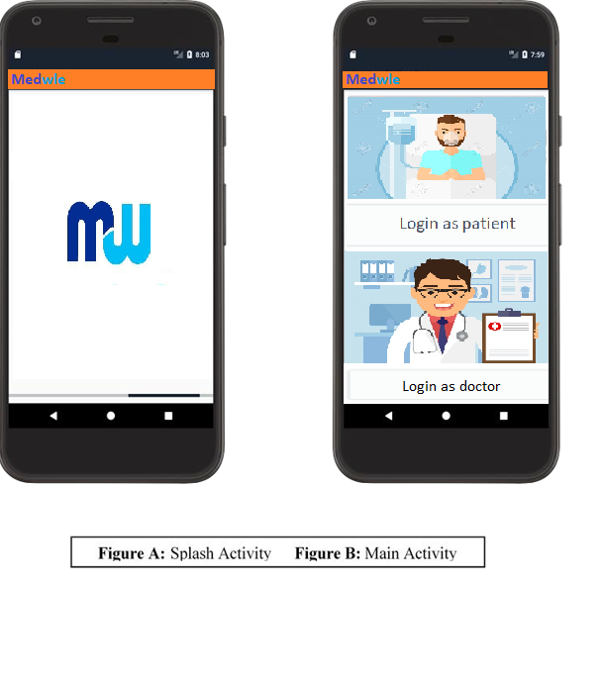

b On the off chance that the client chooses to continue as a patient, next screen asks the client to either make another record by agreeing to accept the application, or continue assist with a current record.

c.In the event if the client chooses to continue as a specialist, next screen asks the client to either make another record by agreeing to accept the application, or continue assist with a current record.

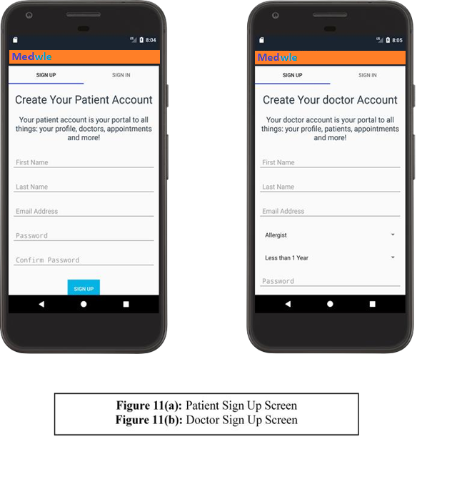

## 

## 

## **3.2 Hardware Interfaces**

1) Basic hardware required is an Android Running Device with atleast Android 5.1.1 (Lollipop)

## **3.3 Software Interfaces**

1) Android Mobile must have Google Play Services running.

2) Active 2G/3G/4G/WiFi connection

3) All database related work will be handled by Firebase.

## **3.4 Communications Interfaces**

1) Information transfer will take place using normal HTTP protocols.

# **4. System Features**

## **4.1 Functional Requirements:**

We describe the functional requirements by giving various use cases.

Use case related to installation:

**Use Case 1**: Installation

Primary Actor: Patient / Doctor

Pre Condition: Internet connection available.

Main Scenario :

1) User opens Google Play Store and installs DoctorOnTheGo app.

2) System asks the user for internet, location and storage read write permissions.

3) App runs for the first time.

Alternate Scenario:

1) Network failure.

a) Installation aborted.

Use cases related to Account Selection:

**Use Case 2**: Patient Account

Primary Actor: Patient

Pre Condition: Nil

Main Scenario :

1) Start the application.

2) Choose Account type as patient

3) Patient Specific Login/Signup screen is displayed.

**Use Case 3**: Doctor Account

Primary Actor: Doctor

Pre Condition: Nil

Main Scenario :

1) Start the application.

2) Choose Account type as Doctor.

3) Doctor Specific Login/Signup screen is displayed.

Use cases related to authorization:

**Use Case 4**: New Patient Login

Primary Actor: Patient

Pre Condition: Nil

Main Scenario :

1) Start the application.

2) Choose account type as patient.

3) Fill up basic profile details.

4) Create new account.

**Use Case 5**: New Doctor Login

Primary Actor: Doctor

Pre Condition: Nil

Main Scenario :

1) Start the application.

2) Choose account type as doctor.

3) Fill up basic profile details.

4) Create new account.

**Use Case 6**: Existing Patient Login

Primary Actor: Patient

Pre Condition: Nil

Main Scenario :

1) Start the application.

2) Choose account type as patient

3) Login using Registered Id and password

4) System does verification

5) Main Screen is displayed.

Alternate Scenario:

A. Authorization Fails

a. User allowed to re-enter password.

**Use Case 7**: Existing Doctor Login

Primary Actor: Doctor

Pre Condition: Nil

Main Scenario :

1) Start the application.

2) Choose account type as Doctor.

3) Login using Registered Id and password.

4) System does verification.

5) Main Screen is displayed.

Alternate Scenario:

A. Authorization Fails

i. User allowed to re-enter password.

**Use Case 8**: Create Appointment

Primary Actor: Patient

Pre Condition: logged in with patient account

Main Scenario :

1) Select book a new appointment.

2) Fill up details for a new appointment. And choose the doctor you want to visit

3) Submit the appointment.

**Use Case 9**: Cancel Appointment Primary

Actor: Patient

Pre Condition: User logged in as a patient.

Main Scenario :

1) Visit View Appointments.

2) Select the Cancel option.

3) Appointment cancelled.

**Use Case 10**: View Appointments

Primary Actor: Patient / Doctor

Pre-Condition: User logged in as patient or doctor

Main Scenario :

1) Select the view appointment’s option 7 | DoctorOnTheGo

2) Existing appointments are displayed.

**Use Case 11**: View Patients

Primary Actor: Doctor

Pre-Condition: User logged in as doctor

Main Scenario :

1) Select the view patients option

2) Existing patients of a particular doctor are displayed.

**Use Case 12**: Create Prescription

Primary Actor: Doctor

Pre Condition: logged in with doctor account

Main Scenario :

1) Select the patient you are attending

2) Choose the option, new prescription.

3)Write the new prescription, and save.

**Use Case 13**: View Prescription

Primary Actor: Patient / Doctor

Pre Condition: User logged in as a patient or a doctor.

Main Scenario :

1) Select view Prescription Option.

2) Existing Prescriptions are displayed.

**Use Case 14**: Edit Prescription

Primary Actor: Doctor

Pre Condition: logged in with doctor account

Main Scenario :

1) Select the patient you are attending

2)Open prescription you want to edit.

3) Make the changes and save it.

**Use Case 15**: Show Nearby Hospitals

Primary Actor: Patients / Doctors

Pre-Condition: Nil

Main Scenario :

1)Open the app.

2) Select Show Stores from menu options.

3)Nearby stores are shown

Alternate Scenario:

1) No, internet or location off fails to show nearby stores.

**Use cases related to alerts**

**Use Case 16**: Show alerts

Primary Actor: Patients.

Pre-Condition: User logged in as patient

Main Scenario :

1)User books a new appointment.

2) The system automatically sends a notification alert to the user Few hours before the appointment.

**Use Case 17**: Change Password

Primary Actor: Patient / Doctor

Pre Condition: User logged in as patient or doctor

Main Scenario :

1)User initiates the password change command.

2) User is prompted for old password, new password and confirm new password.

3) User gives the old password, new password and confirm new password.

4) System does authentication.

5) New password is registered with the system.

# **5. Other NonFunctional Requirements**

## **5.1 Performance Requirements:**

1) Should run on Android Mobiles with Android 5.1.1 (Lollipop) or higher.

2) Minimum 1GB of RAM required.

3) System should have an active internet connection.

## **5.2 Safety Requirements, Security requirements(5.3) and Business Rules(5.5)**

MEDWLE TERMS AND CONDITIONS

Terms of use for Medical Practitioners, Practices and Healthcare Providers for the use of

services provided by Medwle Technologies Private Limited.

Medwle Technologies Private Limited launched an internet resource www.medwle......on the

world wide web for the usage of patients and Medical Practitioners and Health Care Providers.

The following are the terms of use which constitute the agreement between Medwle and the

user of Medwle’s subscription services. Medical Practioner using Medwle subscription services

need to pay a subscription amount for usage of the services provided by Medwle.

This agreement among other things, provides the terms and conditions for use of subscription

services of www.medwle …. Which is owned and operated by Medwle.

This agreement is an electronic record in terms of Information Technology Act, 2000 and

generated by a computer system and does not require any physical or digital signatures. This

agreement is published in accordance with the provisions of Rule 3(1) of the Information

Technology Rules, 2011 that require publishing the rules and regulations, privacy policy and

terms of use for access or usage of subscription services.

1. AGREEMENT

1.1 Medwle reserves right to modify terms of use at any time without prior notice. By

agreeing to these terms, you also agree to such modifications and any additional

terms and conditions, disclaimers, privacy policies and other policies applicable to

general and specific areas of the subscription services or to particular subscription

services are also considered as terms of use.

1.2 You acknowledge that you are bound by the terms of this agreement for availing any

of the subscription services offered by us.

2. TERMS OF USE

2.1 By using subscription services, it is implied that the user have read and understood

these terms of use and you agree to be bound by these terms of use and use these

subscription services in compliance with these terms of use.

2.2 If you do not agree to be bound by any of the terms of the agreement, do not click

the “I AGREE BOX, DO NOT COMPLETE THE REGISTRATION PROCESS AND

DO NOT ATTEMPT TO USE THE SERVICE”, so please read the terms of use

carefully.

2.3 You expressly represent and warrant that you will not use these subscription

services if you do not understand, agree to become a party to and abide by all of the

terms and conditions specified below. Violation of Terms of Use may result in legal

liability upon you and nothing in these terms of use should be construed to confer

any rights to any third party or any other person. By using MEDWLE you are

consenting to this agreement.

2.4 To use these subscription services in any manner you must be 18 years of age or

older to register. By registering or accepting this agreement you represent and

warrant to Medwle that you are 18 years of age or older, and that you have the right

authority and capacity to use the subscription services available through MEDWLE

and agree to abide by this agreement.

2.5 The agreement is governed by the provisions of the Indian Contract Act, 1872, the

Information Technology Act, 2000 and the rules, regulations, guidelines and

clarifications framed there under, including the Information Technology (Reasonable

Security Practices and Procedures and Sensitive Personal Information) Rules, 2011

(the “SPI Rules”) and the Information Technology (Intermediaries Guidelines) Rules,

2011 (the “IG Rules”).

2.6 User’s acceptance of this agreement is a condition for User’s use of and access to

the Subscription services provided by Medwel.

2.7 User is authorized to view and access content available on subscription services

only for receiving, delivering and communicating as per the terms and conditions of

the agreement. The content of subscription services are the property of Medwle and

are protected under Copyright, trademark and other laws.

2.8 User is not permitted to modify Medwel content or reproduce, display, distribute or

otherwise use content in any way for any public or commercial purpose or for

personal gain.

2.9 Account is permitted for usage of single User and not to be shared by multiple users.

2.10 If the subscribing Practitioner authorizes his employee, associate, consultant,

intern or any other person associated with him/her to use subscription services

explicitly or implicitly this agreement becomes a tripartite agreement between you,

the Practitioner and Medwle. For any violation of the terms of this agreement both

Practitioner and Medwle may seek recourse against you.

2.11 All the information given at the time of registration is implied to be true, accurate,

correct, complete and up to date to the best of your knowledge.

2.12 Subscription services provided by Medwle shall not be used for any unauthorized

and unlawful purpose. You will not impersonate another person, including, without

limitation, a Practitioner, a Practice or User.

2.13 Subscription services shall be used only for the purposes that are permitted by a)

the Terms of Use and b) any applicable law, regulation and generally accepted

practices or guidelines in the relevant jurisdictions.

2.14 You shall not reproduce, duplicate, copy, transfer, license, rent, sell, trade or

resell the software or any other subscription services for any purpose whatsoever.

2.15 You agree that you are solely responsible for any breach of your obligations

under the terms of use and for the consequences of any such breach and shall

indemnify Medwle for any claims, losses or damages, of for the costs of any

regulatory or court proceedings suffered by Medwle as a result of your breach under

any applicable law.

2.16 You understand that this agreement and subscription services of Medwle are

subject to any modification or may be removed by Medwle, as a result of change in

government regulations, policies and local laws as applicable.

2.17 You understand that you are responsible for maintaining the confidentiality of

passwords associated with any login you use to access the software.

3. USAGE OF SUBSCRIPTION SERVICES

3.1 Medwle offers free trial of subscription services for a specified period of time at its

discretion, users of software during the trial period are bound by the terms of this

Agreement and any applicable law, regulation and generally accepted practices or

guidelines in the relevant jurisdictions.

3.2 No warranty is provided by Medwle during trial period. Any customizations made to

the software by the user during user’s free trial will be permanently lost at the expiry

of the specified period unless the user upgrade his/her subscription to one of the

user plans.

3.3 User shall not access the subscription services of Medwle if the User or the

organization that he/she represents is direct competitior of Medwle, except with

Medwle’s prior written consent. In addition, the User shall not access the

Subscription services for purposes of monitoring their availability, performance or

functionality or for any other benchmarking or competitive purposes.

3.4 Notwithstanding anything to the contrary contained herein, Medwle does not warrant

that its Subscription Services will always function without disruptions, delays or

errors. A number of factors may impact the use of the Subscription services and

may result in failure of your communications including but not limited to: your local

network, firewall, your internet service provider, the public internet, your power

supply and telephony services. Medwle takes no responsibility for any disruption,

interruption or delay caused by any failure of or inadequacy in any of these items or

any other items over which we have no control.

3.5 In the event of non-availability of software due to apparent default at Medwle’s end

or rendered unsusable, Medwle may at its discretion extend the subscription period

of the Practitioner only by such number of calendar days when the subscription

services were not available. However, you shall agree that Medwle is not

responsible and will not be held liable for the failure of the intermediary services

such as, internet connectivity failure or telephonic disconnections.

3.6 Notwithstanding anything to the contrary contained herein, Practitioner alone shall

be liable for his/her dealings and interaction with patient, his/her representatives or

affiliates, searching for Practitioners through the Website contacted or managed

through the software and Medwle shall have no liability or responsibility in this

regard. Medwle does not guarantee or make any representation with respect to the

correctness, completeness or accuracy of the information or detail provided by end-

users or any third party through the subscription services. The subscription services

are not intended for and must not be used for emergency purposes such as

emergency appointments, emergency healthcare procedures or any other

emergency situations.

3.7 Medwle reserves right to suspend user’s access to the subscription services at any

time if it comes to its knowledge of alleged violations of this agreement or for any

other reason.

3.8 Medwle reserves the right to use the following types of information stored in our

software:

a) Practice information

b) Practioner information

c) End-Users’ demographic information as anonymised form

d) End-Users’ information in relation to his health and history

3.9 Medwle automatically lists Practitioner information on its Subscription services as

per information added to a practice using its software. The information listed is

displayed when End-Users search for Practitioners or practices on the Medwle

website, and this information listed on the subscription services may be used by

End-Users to request for appointments.

3.10 All reasonable steps shall be taken by Medwle to duly inform Practices via phone

and email for appointment requests made on service. Due to technical or operational

reasons including but not limited to cases when practices do not respond to phone

calls made by Medwle or when practices do not read emails or text messages sent

by Medwle in time, Medwle, however shall have no liability or responsibility in this

regard.

3.11 You understand that Medwle take all efforts to ensure a confirmed appointment

for the customer who requested appointment on the service but shall not guarantee

that the appointments will be confirmed in all cases. Medwle has no liability for

cancellation of any confirmed appointments later by any of the customer or if the

Practitioners are not available as per the given appointment time.

3.12 Some of the subscription services may be subject to additional limitations,

restrictions, terms or conditions specific to such software. In such cases, the

applicable specific terms will be and your access to and use of relevant subscription

services will be contingent upon your acceptance of and compliance with such

specific terms.

4. PAYMENT

4.1 It is the sole discretion of Medwle to add new subscription services for additional

fees and charges or may amend fees and charges for existing services. Fees fixed

at the time of subscription to subscription services shall be amended by Medwle at it

sole discretion from time to time.

4.2 By purchasing the subscription based paid service you are authorizing Medwle to

charge you applicable fees at the beginning of every subscription period or at such

intervals as applicable to the said service and you authorize Medwle make such

modification to the fee structure as required during the subsistence of a subscription

period and also agree to abide by such modified fee structure.

4.3 You agree to pay all subscription fees, consulting fees and other fees applicable to

User’s use of subscription services. The fee is dependent on the user plan

purchased by the User and the subscription fee is non-refundable.

4.4 You agree that you are responsible for payment of all taxes, legal compliances and

statutory registrations and reporting. Medwle is no way responsible for any of your

taxes or legal or statutory compliances except for its own due diligence.

4.5 For fee payment facility Medwle may make available offline fee payment facility

supported by a third party vendor but Medwle is not responsible for any loss or

damage caused to the User using this payment facility provided by such third party

Vendor.

4.6 The fees can also be paid by cheque either collected personally from User or

required to be mailed to Medwle at the following address, Medwle Technologies

Private Limited, Flat No.502, Sree Nialayam, above New Sampoorna Super Market,

Lanco Hills Road, Manikonda, Hyderabad-500089.

4.7 All fees is exclusive of taxes, Service Tax and other statutory taxes as applicable are

levied on every purchase.

4.8 The payment process would be considered to be complete only on receipt of the

fees into the designated bank account of Medwle.

4.9 Fees not received within the specified due dates attract late charges of 18% per

annum from the due date of payment and any such charges may be levied at

Medwle’s sole discretion.

4.10 Medwle reserves the right to modify the fee structure by providing 30 days prior

notice, either by notice on the subscription services or through email to the

authorized user, which shall be considered as valid and agreed communication. In

the event of non communication by the User to such notice, the modified fee

structure shall be applicable with effective from the expiry of the said notice period.

4.11 An intimation of receipt of fee from the User shall be sent through an email

within 7 working days of receipt of fee into Medwle’s designated bank account.

4.12 You can cancel subscription services by using any of the cancellation methods

listed in the Terms of use or by contacting our customer care by email at

……@medwle.com. The on board charges shall not be refunded to the user on

cancellation of subscription services.

4.13 See ANNEXURE-I for price list of various plans provided by Medwle.

5. PERSONAL INORMATION

5.1 The User is expected to read and understand the Privacy Policy, so as to ensure

that he /she has knowledge of the fact that the information is being collected, the

purpose for which the information is being collected, the intended recipients of the

information, the name and address of the agency that is collecting the information

and the agency that retain the information; and the various rights available to such

Users in respect of such information.

5.2 Medwle or any other person acting on behalf of Medwle shall not be responsible in

any manner for the authenticity of personal information or sensitive personal data or

information supplied by the User.

5.3 The use of subscription services involves every user’s registration information and

browsing history being stored and submitted to the appropriate authorities. The

information collected by Medwle from users as part of registration process is

described in the privacy policy.

5.4 The User is responsible for maintaining the confidentiality of the User’s login account

access information and password. The user shall be responsible for all usage of the

User’s login or password, whether or not authorized by the User.

5.5 The User shall immediately notify Medwle of any actual or suspected unauthorized

use of the User’s login or password.

5.6 Medwle has right to discontinue subscription services to the user as its sole

discretion if it comes to its knowledge that information provided by User is untrue,

inaccurate, not current or incomplete or has reasonable grounds to suspect that

such information is untrue, inaccurate, not current or incomplete.

5.7 Any information provided by the user may be retained by Medwle and used at its

discretion after termination of this agreement or expiry of a subscription by the user

and thereupon the agreement and Privacy Policy of the website shall be applicable

to such information.

6. OBLIGATIONS OF USER

6.1 As mandated by Regulation 3(2) of the Information Technology (Intermediaries

Guidelines) Rules, 2011, Medwle hereby informs the User that the User is not

permitted to host, display, upload, modify, publish, transmit, update or share any

information that:

(a) belongs to another person and to which the user does not have any right

to;

(b) is grossly harmful, harassing, blasphemous defamatory, obscene,

pornographic, paedophilic, libellous, invasive of another&#39;s privacy, hateful, or racially,

ethnically objectionable, disparaging, relating or encouraging money laundering or

gambling, or otherwise unlawful in any manner whatever;

(c) harm minors in any way;

(d) infringes any patent, trademark, copyright or other proprietary rights;

(e) violates any law for the time being in force;

(f) deceives or misleads the addressee about the origin of such messages or

communicates any information which is grossly offensive or menacing in nature;

(g) impersonate another person;

(h) contains software viruses or any other computer code, files or programs

designed to interrupt, destroy or limit the functionality of any computer resource;

(i) threatens the unity, integrity, defence, security or sovereignty of India,

friendly relations with foreign states, or public order or causes incitement to the

commission of any cognisable offence or prevents investigation of any offence or is

insulting any other nation.

6.2 The User is also prohibited from:

(a) Violating or attempting to violate the integrity or security of the subscription

services or any Medwle software.

(b) Transmitting any information (including job posts, messages and hyperlinks) on

or through the subscription services that is disruptive or competitive to the

provision of subscription services by MEdwle.

(c) Intentionally submitting on the Subscription services any incomplete, false or

inaccurate information.

(d) Making any unsolicited communications to other Users.

(e) Copying or duplicating in any manner any of the Medwle content or other

information available from the service.

6.3 Medwle on receiving information by itself or being brought to actual knowledge by an

affected person in writing or through email signed with electronic signature about

any such information as mentioned above, shall be entitled to disable such

information as well entitled to preserve such information and associated records for

atleast 90 days for service on to governmental or investigative authorities for

investigation purposes.

6.4 Medwle is entitled to immediately terminate the access and usage of rights to the

User to the Subscription services in case of non-compliance with any applicable

laws, rules or regulations by a user.

6.5 Medwle honour intellectual property rights of others and do not hold any

responsibility for any violation of any intellectual property rights by user.

7. LIABILITY

7.1 Medwle is not responsible or liable in any manner to the users for any losses,

damage, injuries or expenses incurred by the users as a result of disclosures made

by it., where the user has consented to the making of disclosures by Medwle.

7.2 Medwle is no way responsible for any disclosures made by it and user cannot hold

Medwle liable.

7.3 The Subscription services of Medwle may be linked with the services of third parties,

affiliates and business partners over which Medwle has no control over and not

liable or responsible for content, accuracy, validity, reliability, quality of such

subscription services. User shall use all links included in subscription services at

his/her own risk.

7.4 Medwle shall not be liable or responsible for any damages or viruses that may infect

User’s equipment on account of User’s access to, use of or browsing the

subscription services or downloading of any material data, text, images, video

content or audio content from the service. In the event of dissatisfaction the User

can discontinue the subscription services of Medwle.

7.5 In no event, including but not limited to negligence, shall Medwle or any of its

directors, officers, employees, agents or content service providers be liable for any

direct, indirect, special, incidental, consequential, exemplary or punitive damages

arising from or directly or indirectly related to the use of or the inability to use, the

subscription services of the content, materials and functions related thereto, User’s

provision of information via the subscription services of the Medwle, lost business or

lost sales, even if such protected entity has been advised of the possibility of such

damages.

7.6 Medwle shall not be responsible for adverse feedback or comments, or ratings on

the subscription services which are a subject matter or automated processes and

Medwle disclaims any liability for lost business or reputation of a User due to

information, data or ratings that are available on the service.

8. SPAM MESSAGES

The sender of any message deemed to be spam is liable for Rs.5,000/- for each end

user that receives each unauthorized message and will pay all fees owed to Medwle

within thirty (30) days of such transmission.

9. INDEMNIFICATION

User agrees to indemnify and hold harmless Medwle, its affiliates, officers, directors,

employees, consultants, licensors, agents and representatives from any and all third

party vendors from claims, losses, liability, damages arising from his/her account, of any

intellectual property or other right of any person or entity. Medwle shall notify user of any

such claim, loss, liability or demand and in addition to your foregoing obligations, user

agree to provide us with reasonable assistance at your expense in defending any such

claim, loss, liability, damage or cost.

10. TERM AND TERMINATION

10.1 The agreement shall remain in full force and effect as long as user subscribes for

the subscription services periodically in any form or capacity.

10.2 The user can request for termination of his/her membership with Medwle at any

time by providing 30 days prior written notice to ………..@medwle.com. Medwle will

investigate and ascertain the fulfillment of ongoing subscription services or pending

dues related to subscription fees or any other fee dues by user.

10.3 User is obliged to clear any dues pending with Medwle for any of its subscription

services and Medwle is not liable to you are any third party for any termination of

user access to the subscription services.

10.4 Medwle reserves the right to terminate any account in the following events:

(a) Breach of any of the terms and conditions of the terms of use or privacy policy.

(b) If Medwle is unable to verify or authenticate any information provided by a user.

(c) It is in the sole discretion of Medwle that User’s actions may cause legal liability

for such user or Medwle or contrary to the interests of the service.

(d) If the user does not follow Medwle’s guidelines given at the time of subscription

of services.

10.5 User may not be permitted to use the subscription services under the same

account once services are temporarily suspended or terminated. User shall re-

register under a new account unless explicitly permitted by Medwle.

10.6 Even after termination, obligations of user under the agreement, liability,

indemnity, intellectual property, dispute resolution will continue and survive

termination.

11. SEVERABILITY AND WAIVER

If any of the provision of the terms of use is held to be invalid or unenforceable, such

provision shall be struck and the remaining provisions shall be enforced.

12. LAW AND JURISDICTION

This agreement and any contractual obligations between Medwle and User shall be

governed by the laws of India, subject to the exclusive jurisdiction of courts in

Hyderabad, Telangana, India.

13. CONTACT INFORMATION

For any issues, concerns or complaints regarding our subscription services contact our

customer service at ………medwle.com.

5.4 Software Quality Attributes

adaptability, availability, correctness, flexibility, interoperability, maintainability, portability, reliability, reusability, robustness, testability, and usability.These are some the Important quality attributes we have beem focusing while developing the project.

# 6 Other Requirements

TBD

Appendix A: Glossary

TBD

Appendix B: Analysis Models

TBD

Appendix C: To Be Determined List

TBD